Exp. No: 4
Measurement and Analysis of Dispersion Compensation in Optical Fiber using OptiSystem
OBJECTIVES
- To demonstrate dispersion compensation using the Ideal Dispersion Compensation component in OptiSystem.
- To observe the broadening of a 12.5 ps optical Gaussian pulse after propagation through 10 km of single-mode fiber (SMF).
- To compensate the accumulated dispersion of 160 ps/nm and verify recovery of the original pulse shape.
SOFTWARE REQUIRED
OptiSystem Software
CIRCUT DIAGRAM:
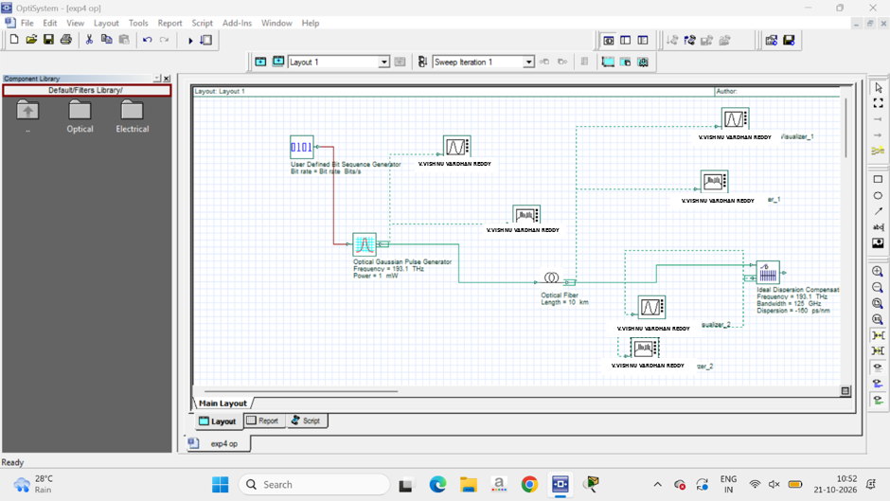
OUTPUT GRAPH:
Figure 1: Initial Gaussian pulse

A.
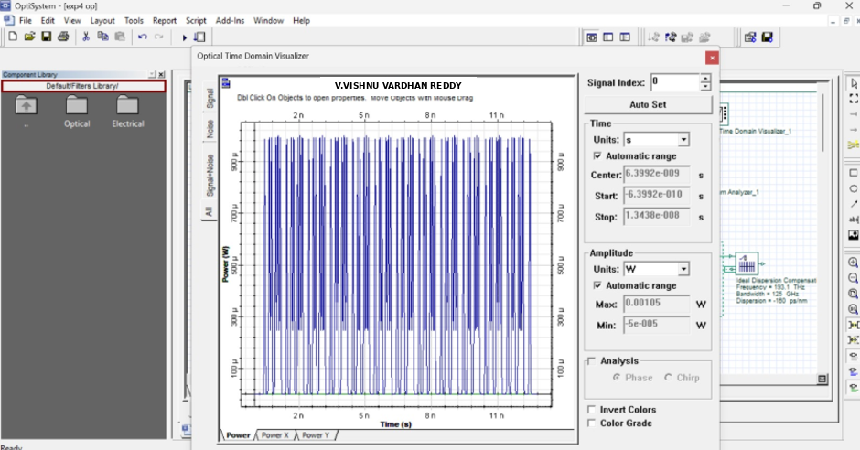

B.
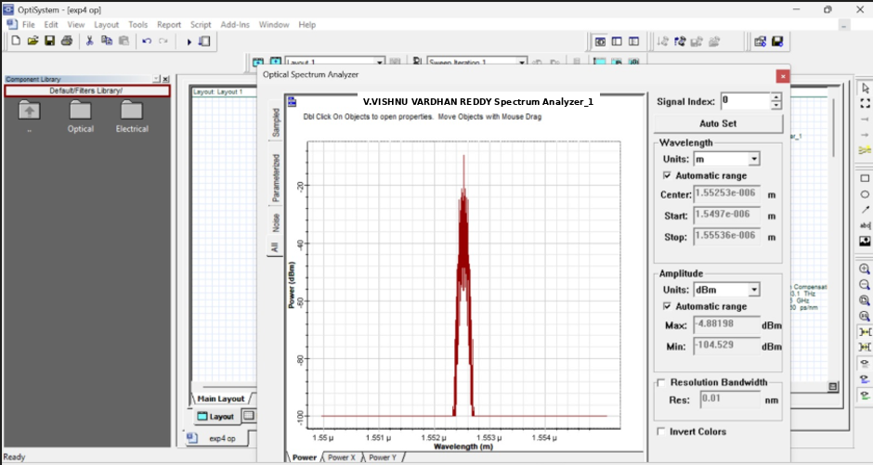

Figure 2: Gaussian pulse after 10 km propagation in SMF
A.
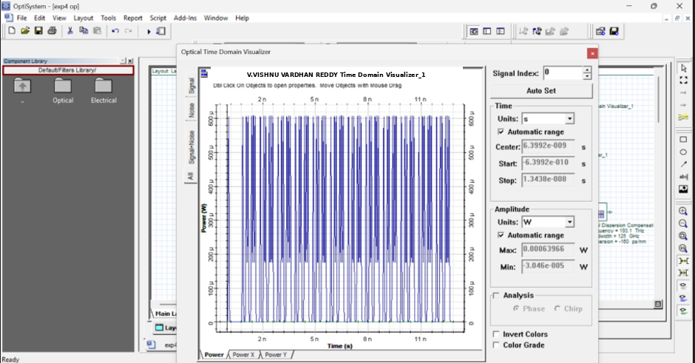
B.
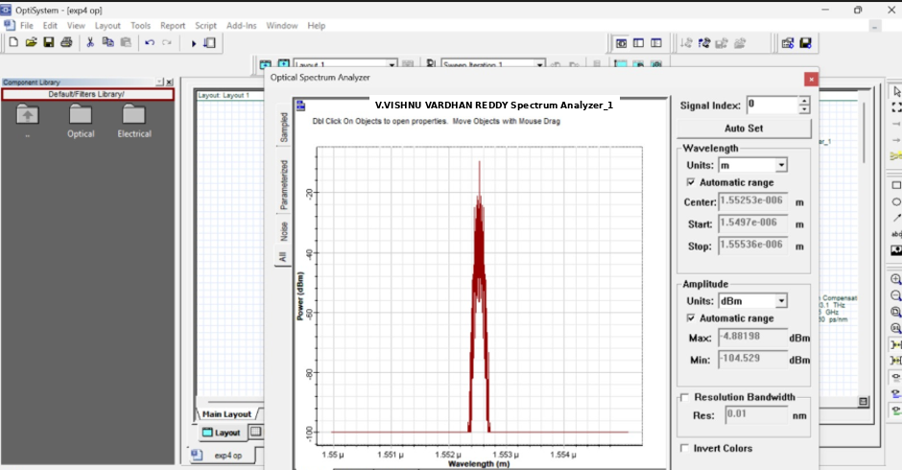

Figure 3: Parameters of Ideal Dispersion Compensation component
A.
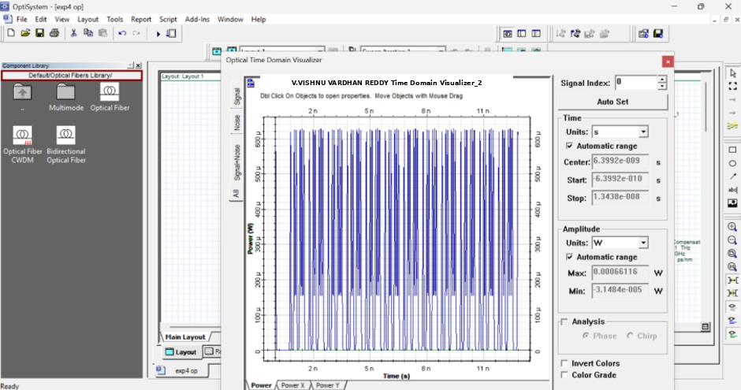

Figure 4: Pulse after dispersion compensation with Ideal Dispersion Compensation component
A.
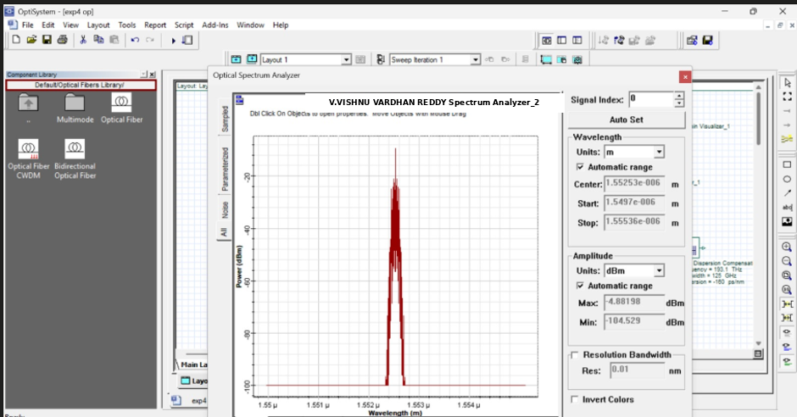

Reflection
This experiment clearly illustrates how chromatic dispersion causes severe pulse broadening over distance, which leads to inter-symbol interference in high-speed optical systems. It highlights the critical role of exact negative dispersion matching (using Fiber Bragg Gratings or compensation modules) to maintain signal integrity and ensure error-free data transmission in long-haul optical networks.

OUTPUT PARAMETERS

Stage | Observation Point | Result | Figure
Initial pulse | Gaussian pulse generator output | Gaussian pulse, 12.5 ps | Figure 1  (A),(B)
After propagation | Output of 10 km SMF | Pulse width increased ≈ 4 times | Figure 2  (A),(B),(C)
Compensator setting | Ideal Dispersion Compensation FBG | Dispersion = –160 ps/nm | Figure 3  (A)
After compensation | Compensator output | Original pulse recovered (exact compensation) | Figure 4  (A)

LABORATORY PERFORMANCE ASSESSMENT RUBRIC
Objective | Assessment Criterion | Excellent – 4 | Good – 3 | Satisfactory – 2 | Needs Improvement – 1 | Weightage
Design the OptiSystem layout | Project layout | Builds the complete layout with correct components and connections independently | Minor connection errors corrected | Needs guidance for components or connections | Unable to build the layout | 20
Configure pulse, SMF and compensator parameters | Parameter configuration | Sets all parameters (40 Gb/s, 12.5 ps, 193.1 THz, 10 km, –160 ps/nm, 125 GHz) correctly | Minor parameter errors | Needs guidance for several parameters | Unable to configure parameters | 20
Observe pulse broadening in SMF | Pulse observation | Captures and interprets initial and broadened pulses correctly | Minor interpretation errors | Limited observation / needs help | Unable to obtain or interpret pulses | 20
Verify compensation using ideal dispersion component | Compensation verification | Verifies recovery of the pulse and explains residual effects of settings | Mostly correct verification | Partial verification with assistance | Unable to verify compensation | 20
Document findings | Report and conclusion | Complete report with justified conclusion | Minor omissions | Incomplete record / weak conclusion | Report / conclusion inadequate | 20

Result
A 12.5 ps optical Gaussian pulse experienced a four-fold broadening after propagating through a 10 km SMF due to an accumulated dispersion of 160 ps/nm. By introducing an Ideal Dispersion Compensation component set to –160 ps/nm, the accumulated dispersion was perfectly countered, successfully recovering the original pulse shape and width.

